South Australia
Marketable Securities Act 1971
An Act to make provision with respect to instruments of transfer of certain marketable securities; to repeal the Marketable Securities Transfer Act 1967; and for other purposes.

Contents
1 Short title and commencement
2 Repeal and savings
3 Interpretation
4 Sufficient instrument of transfer
5 Transfers of marketable securities
6 Transfers by authorised trustee corporations
7 Execution of transfers by transferee
8 Effect of certain stamps on prescribed instruments
9 Registration by company of prescribed instrument
10 Operation of Act
11 Omission from register of certain matters
12 Transfers, whether or not prescribed instruments, need not include certain matters
13 Offences
14 Regulations
Schedule
Legislative history

The Parliament of South Australia enacts as follows:
1—Short title and commencement
(1) This Act may be cited as the Marketable Securities Act 1971.
(2) This Act shall come into operation on a day to be fixed by proclamation.
2—Repeal and savings
(1) The Marketable Securities Transfer Act 1967 is repealed.
(2) The repeal of the Marketable Securities Transfer Act 1967 does not affect the amendments made by that Act to the Stamp Duties Act 1923.
(3) A prescribed instrument under the Marketable Securities Transfer Act 1967 that was duly completed before the commencement of this Act shall have the same effect and may be used and dealt with as if the provisions of that Act repealed by this Act had continued in operation.
(4) An agreement, warranty or indemnity deemed by the Marketable Securities Transfer Act 1967 to have been made or given by any person shall continue to operate and shall have the same force and effect as if the provisions of that Act repealed by this Act had continued in operation.
3—Interpretation
(1) In this Act unless inconsistent with the context or subject-matter—
authorised trustee corporation means a body corporate that is under the regulations an authorised trustee corporation;
beneficial owner in relation to a marketable security or a right to a marketable security means a person for whom an authorised trustee corporation is holding the security or right in trust in the ordinary course of its business;
broker means any person who is a dealer within the meaning of Part 3A of the Stamp Duties Act 1923;
corresponding law means a law in respect of which a declaration under subsection (2) of this section is in force and includes regulations in force under that law;
legal representative means the executor, original or by representation of a will, or administrator of the estate of a deceased person;
marketable security means—
(a) a share in or a debenture of a company or prescribed corporation; or
(b) a prescribed security;
prescribed corporation means—
(a) a body corporate incorporated in the State not being a company; or
(b) an unincorporated society, association or other body formed or established in the State, any shares in or debentures of which are quoted on or in respect of which permission to list has been granted by a prescribed stock exchange,
that is under the regulations a prescribed corporation;
prescribed security means an interest to which Division 5 of Part 4 of the Companies Act 1962, as amended, applies that is under the regulations a prescribed security or that is one of a class of such interests that are under the regulations prescribed securities;
prescribed stock exchange means a stock exchange in the State that is under the regulations a prescribed stock exchange;
right to a marketable security means a right whether existing or future, and whether contingent or not, of a person to have issued to him a marketable security whether or not on payment of any money or for any other consideration;
transfer in relation to a right to a marketable security means the renunciation and transfer of that right.
(2) The Minister may by notice in writing published in the Gazette declare a law in force in another State or in a Territory of the Commonwealth the provisions of which correspond substantially with the provisions of this Act to be a corresponding law and may by notice so published revoke a declaration made under this subsection.
(3) Subject to subsection (1) and unless the contrary intention appears, words and expressions used in this Act that are defined by section 5 of the Companies Act 1962 have the same respective meanings as they have in that Act.
(4) A reference in this Act to a form by number is a reference to the form so numbered in the Schedule or to a form to the like effect.
(5) A reference in a form in the Schedule to this Act relating to marketable securities or rights to marketable securities to the full name of the transferor includes a reference to the name of the person shown in the records of the company or prescribed corporation that issued those securities or rights as the holder of those securities or rights.
4—Sufficient instrument of transfer
A document that is a sufficient instrument of transfer under this Act may be used—
(a) where it relates to a transfer of marketable securities, as a proper instrument of transfer for the purposes of section 95 of the Companies Act 1962, as amended, and as an instrument of transfer for the purposes of any other law or instrument governing or relating to those securities; and
(b) where it relates to a transfer of rights to marketable securities as an instrument of transfer of those rights for the purposes of any law or instrument governing or relating to those rights or securities.
5—Transfers of marketable securities
(1) A document is a sufficient instrument of transfer of marketable securities if—
(a) it is an instrument relating to those marketable securities duly completed in accordance with or to the effect of—
(i) Form 1;
(ii) Part 1 of Form 1 and Parts 1 and 2 of Form 2; or
(iii) Part 1 of Form 1 and Parts 1 and 2 of Form 3; and
(b) where the document relates to marketable securities on which there is an uncalled liability (not being marketable securities that are partly paid shares in a no-liability company), the transferee's acceptance of the marketable securities duly completed in accordance with or to the effect of Form 4 is included in or attached to the instrument referred to in paragraph (a) of this subsection.
(2) A document is a sufficient instrument of transfer of rights to marketable securities if—
(a) it is an instrument relating to those rights duly completed in accordance with or to the effect of—
(i) Form 5; or
(ii) Part 1 of Form 5 and Parts 1 and 2 of Form 6; or
(iii) Part 1 of Form 5 and Parts 1 and 2 of Form 7; and
(b) where the document relates to rights to marketable securities (not being marketable securities that are shares in a no-liability company) for which the whole of the moneys to be subscribed is not payable in full on application being made for them, the transferee's acceptance of the securities duly completed in accordance with or to the effect of Form 4 is included in or attached to the instrument referred to in paragraph (a) of this subsection.
(3) For the purposes of this section an instrument is not duly completed in accordance with or to the effect of Form 1, 2, 3, 5, 6 or 7 or a part of one of those forms unless—
(a) where the form or part refers to the name and address of the transferee, the instrument purports to state that name and address; and
(b) where the form or part refers to the stamp of the transferor's broker, the instrument bears a stamp which purports to be such a stamp; and
(c) where the form or part refers to the stamp of the transferee's broker, the instrument bears a stamp which purports to be such a stamp; and
(d) where the form or part refers to a stock exchange stamp, the instrument bears a stamp which purports to be a stamp of a prescribed stock exchange, or of a prescribed stock exchange under a corresponding law.
6—Transfers by authorised trustee corporations
(1) In respect of the transfer of marketable securities by an authorised trustee corporation to the beneficial owner of those marketable securities, being a transfer that is not made by way of a sale, gift or exchange of the marketable securities, a document is a sufficient instrument of transfer if—
(a) it is an instrument relating to those marketable securities duly completed in accordance with or to the effect of Form 8; and
(b) where the document relates to marketable securities on which there is an uncalled liability (not being marketable securities that are partly paid shares in a no-liability company), the transferee's acceptance of the marketable securities duly completed in accordance with or to the effect of Form 9 is included in or attached to the instrument referred to in paragraph (a) of this subsection.
(2) In respect of the transfer of rights to marketable securities by an authorised trustee corporation in favour of the beneficial owner of those rights, being a transfer that is not made by way of a sale, gift or exchange of the rights, a document is a sufficient instrument of transfer if—
(a) it is an instrument relating to those rights duly completed in accordance with or to the effect of Form 10; and
(b) where the document relates to rights to marketable securities (not being marketable securities that are shares in a no-liability company) for which the whole of the moneys to be subscribed is not payable in full on application being made for them, the transferee's acceptance of the rights duly completed in accordance with or to the effect of Form 11 is included in or attached to the instrument referred to in paragraph (a) of this subsection.
7—Execution of transfers by transferee
(1) Where marketable securities in a company or prescribed corporation are transferred by means of a sufficient instrument of transfer under this Act, the transferee shall be deemed to have agreed at the relevant time to accept the marketable securities subject to the several terms and conditions on which the transferor held them at that time, being the terms and conditions applicable as between the company or prescribed corporation and the holder for the time being of the marketable securities.
(2) Where rights to marketable securities in a company or prescribed corporation, for which the whole of the moneys to be subscribed is payable in full on application being made for them, are transferred by means of a sufficient instrument of transfer under this Act, the transferee shall be deemed—
(a) to have made application at the relevant time to the company or prescribed corporation for the allotment to him of the marketable securities; and
(b) to have agreed at the relevant time to accept the marketable securities subject to the terms and conditions upon which they are offered by the company or prescribed corporation for subscription.
(3) Where marketable securities that are shares in a company or prescribed corporation are transferred by means of a sufficient instrument of transfer under this Act, the transferee shall be deemed to have agreed at the relevant time—
(a) to become a member of the company or prescribed corporation; and
(b) to be bound by the memorandum and articles or by the constitution of the company or prescribed corporation.
(4) In this section—
the relevant time means—
(a) in relation to a sufficient instrument of transfer under section 5 of this Act, the time of the affixing of a stamp which purports to be that of the transferee's broker; and
(b) in relation to a sufficient instrument of transfer under section 6 of this Act, the time of execution by the transferor.
8—Effect of certain stamps on prescribed instruments
(1) Where a duly completed instrument of transfer bears a stamp that purports to be that of the transferor's broker, a prescribed stock exchange or a prescribed stock exchange under a corresponding law and to have been affixed in the State, the broker (not being a broker's agent) or stock exchange whose stamp that stamp purports to be and, if the stamp purports to be that of the transferor's broker (whether or not he is a broker's agent), any associate of that broker—
(a) shall be deemed to have warranted the accuracy of the statements in his or its certificate set out in the instrument; and
(b) shall be deemed to have warranted that the transferor is the registered holder of or is entitled to be registered as the holder of the marketable securities to which the instrument relates or is entitled to the rights to marketable securities to which the instrument relates and is legally entitled or authorised to sell or dispose of those marketable securities or rights; and
(c) shall be liable to indemnify—
(i) the company, prescribed corporation, foreign company or prescribed corporation under the corresponding law that has issued or proposes to issue the marketable securities or rights to marketable securities to which the instrument relates; and
(ii) the transferee; and
(iii) the transferee's broker,
against any loss or damage arising from a forged or unauthorised signature of the transferor appearing in the instrument.
(2) Without limiting the operation of subsection (1) of this section, where a duly completed instrument of transfer, which bears a stamp that purports to be that of the transferor's broker and to have been affixed in the State, relates to marketable securities or rights to marketable securities to which or to any of which a duly completed instrument of transfer, which bears a stamp that purports to be that of a prescribed stock exchange or a prescribed stock exchange under a corresponding law relates, the broker (not being a broker's agent) whose stamp that first-mentioned stamp purports to be and (whether or not that broker is a broker's agent) any associate of that broker shall be liable to indemnify that stock exchange against any loss or damage arising from a forged or unauthorised signature of the transferor appearing in the instrument.
(3) A reference in subsection (1) or (2) of this section—
(a) to a duly completed instrument of transfer is a reference to an instrument—
(i) that is in accordance with or to the effect of Part 1 of Form 1, 2, 3, 5, 6 or 7 and that has been duly completed within the meaning of section 5 of this Act; or
(ii) that is in accordance with or to the effect of a like part of a form under a corresponding law and that has been duly completed within the meaning of a provision of a corresponding law that corresponds to section 5 of this Act; and
(b) to an associate of a broker is a reference—
(i) where the broker, whose stamp the stamp on the instrument purports to be, is a member of a firm of brokers and is not a broker's agent—to each other member of that firm; and
(ii) where the broker, whose stamp the stamp on the instrument purports to be, is a broker's agent—to the broker for whom he is a broker's agent and, if the broker for whom he is a broker's agent is a member of a firm of brokers, to each other member of that firm.
(4) In this section—
broker's agent means a broker's agent as defined in Part 3A of the Stamp Duties Act 1923, as amended;
marketable security, in relation to a duly completed instrument of transfer under a corresponding law, means a marketable security within the meaning of the corresponding law;
right to a marketable security, in relation to a duly completed instrument of transfer under a corresponding law, means a right to a marketable security within the meaning of the corresponding law.
9—Registration by company of prescribed instrument
(1) A company or prescribed corporation with which a sufficient instrument of transfer under section 5 of this Act is lodged for the purpose of registering a transfer of marketable securities or obtaining the allotment of marketable securities, is and its officers are, in the absence of knowledge to the contrary, entitled to assume without inquiry—
(a) that a stamp upon the instrument which purports to be the stamp of the transferee's broker is the stamp of that broker; and
(b) that a stamp upon the instrument which purports to be the stamp of the transferor's broker is the stamp of that broker; and
(c) that a stamp upon the instrument which purports to be the stamp of a prescribed stock exchange or a prescribed stock exchange under a corresponding law is the stamp of that stock exchange.
(2) A company or prescribed corporation with which a sufficient instrument of transfer under section 6 of this Act is lodged for the purpose of registering a transfer of marketable securities or obtaining the allotment of marketable securities, is and its officers are, in the absence of knowledge to the contrary, entitled to assume without inquiry that—
(a) at the time of the execution of the instrument, the authorised trustee corporation named in the instrument was holding the marketable securities or the rights to the marketable securities in the ordinary course of its business in trust for or on behalf of the transferee; and
(b) the transfer was not made by way of a sale, gift or exchange of the marketable securities or rights.
10—Operation of Act
(1) This Act applies and has effect in relation to the transfer of marketable securities and to the transfer of rights to marketable securities notwithstanding anything to the contrary in any other enactment or in any instrument relating to the transfer of the securities or the transfer of the rights.
(2) Except as provided in this Act, this Act does not affect the terms and conditions on which marketable securities or rights to marketable securities are sold.
(3) Nothing in this Act affects any right of a company or prescribed corporation to refuse to acknowledge or register a person as the holder of marketable securities or to allot marketable securities to a person on any ground other than an objection to the form of an instrument lodged with the company or prescribed corporation relating to the transfer of the marketable securities or of rights to the marketable securities.
(4) The registration of a transfer of a marketable security or the allotment of a marketable security pursuant to a sufficient instrument of transfer under this Act does not constitute a breach of any provision of any memorandum or articles or of a trust deed or other instrument or an enactment that relates to marketable securities.
(5) This Act does not prevent or affect the use of any other form of transfer of marketable securities or form of transfer of rights to marketable securities, as the case may be, or mode of execution of an instrument of transfer of marketable securities or mode of execution of an instrument of transfer of rights to marketable securities that is otherwise permitted by law.
(6) A transfer of marketable securities or of rights to marketable securities by or to a trustee or legal representative may, notwithstanding any law or the provisions of the instrument, if any, creating or having effect in relation to the trust or will under which he is appointed trustee or legal representative be effected by means of a sufficient instrument of transfer under this Act.
11—Omission from register of certain matters
The omission from any register, certificate or other document relating to marketable securities of a statement of the occupation of the person who is, or is entitled to be, registered as the holder of the marketable securities does not constitute a breach of any provision of any memorandum or articles or of a trust deed or other instrument or enactment that relates to the marketable securities.
12—Transfers, whether or not prescribed instruments, need not include certain matters
Notwithstanding anything contained in the memorandum or articles of a company or prescribed corporation or in the terms or conditions upon which marketable securities or rights to marketable securities in a company or prescribed corporation are created or issued it shall not be necessary in any instrument of transfer of marketable securities or of rights to marketable securities to state the occupation of the transferee or transferor or to have the signature of the transferee or transferor witnessed.
13—Offences
(1) A broker shall not in the State affix a broker's stamp to an instrument that may be used as a sufficient instrument of transfer under this Act or under a corresponding law unless the instrument relates to a sale or purchase made in the ordinary course of business of the broker for a consideration of not less than the unencumbered market value (at the time of the sale or purchase) of the marketable securities or rights to marketable securities to which the instrument relates.
Penalty: One thousand dollars.
(2) A prescribed stock exchange or a prescribed stock exchange under a corresponding law shall not in the State affix a stock exchange stamp to an instrument that may be used as a sufficient instrument of transfer under this Act or under a corresponding law unless—
(a) there has been lodged; or
(b) the stock exchange holds a duly completed instrument of transfer bearing a certificate which purports to be that of the transferor's broker, that there has been or will be lodged,
with the company or prescribed corporation that has issued or proposes to issue the marketable securities or rights to marketable securities to which that first-mentioned instrument relates a duly completed instrument of transfer, being Part 1 of Form 1, relating to those marketable securities or rights.
Penalty: One thousand dollars.
(3) An authorised trustee corporation shall not in the State execute an instrument that may be used as a sufficient instrument of transfer under section 6 of this Act or under a like provision of a corresponding law if the instrument relates to a transfer of marketable securities or of rights to marketable securities—
(a) made by way of a sale, gift or exchange of the marketable securities or rights; or
(b) to or in favour of a person who is not the beneficial owner of the marketable securities or rights.
Penalty: One thousand dollars.
(4) A person other than an authorised trustee corporation shall not in the State knowingly cause, authorise or permit to be executed an instrument that may be used as a sufficient instrument of transfer under section 6 of this Act or under a like provision of a corresponding law if it is not a sufficient instrument of transfer within the meaning of that section or provision as the case may be.
Penalty: One thousand dollars.
(5) A person shall not knowingly lodge or cause to be lodged with a company or prescribed corporation an instrument to which a stamp has been affixed in contravention of subsection (1) or (2), or which has been executed in contravention of subsection (3), of this section for the purpose of securing the registration of the transfer of marketable securities or the allotment of marketable securities to the transferee named therein.
Penalty: One thousand dollars.
(6) References in this section to the expression a duly completed instrument of transfer, marketable securities or rights to marketable securities shall be construed in the same way as references to those expressions are to be construed for the purposes of section 8 of this Act.
(7) In this section—
beneficial owner, in relation to a sufficient instrument of transfer under a corresponding law, means a beneficial owner within the meaning of the corresponding law.
14—Regulations
(1) The Governor may make regulations for or with respect to any one or more of the following—
(a) prescribing bodies corporate as authorised trustee corporations;
(b) prescribing interests to which or interests of a class to which Division 5 of Part 4 of the Companies Act 1962 applies as prescribed securities;
(c) prescribing stock exchanges in the State as prescribed stock exchanges;
(d) prescribing any matter or thing that is required necessary or expedient to be prescribed or provided for the purposes of this Act and without limiting the generality of the foregoing providing for a penalty not exceeding two hundred dollars for a breach of or non-compliance with a provision of the regulations.
(2) The regulations shall not prescribe a body corporate as an authorised trustee corporation unless it is a body corporate that in the opinion of the Minister holds in the ordinary course of its business marketable securities for or on behalf of another person.

Schedule
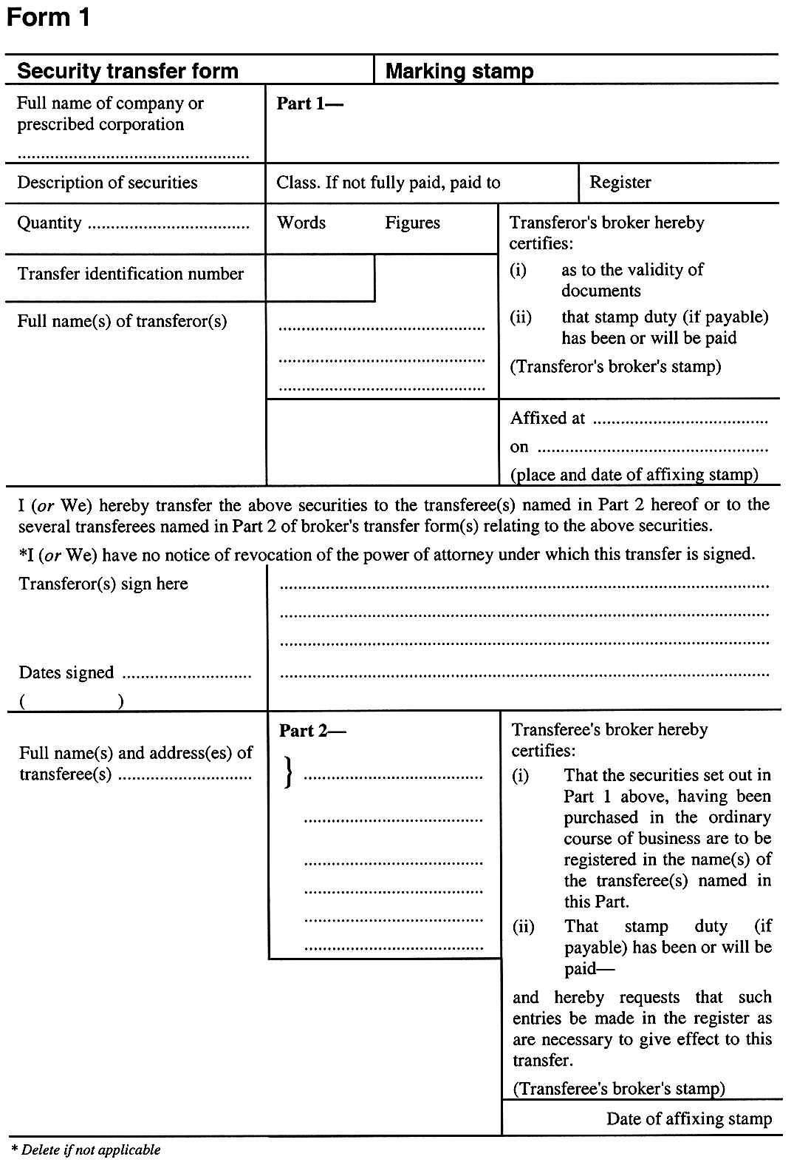
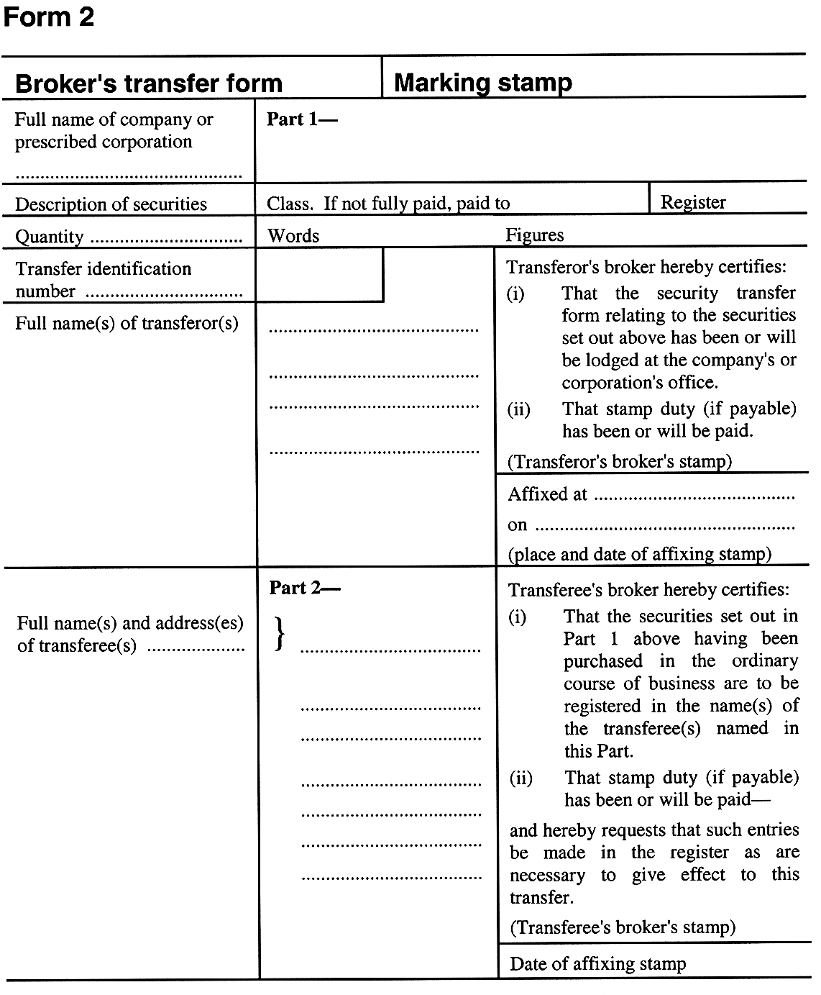
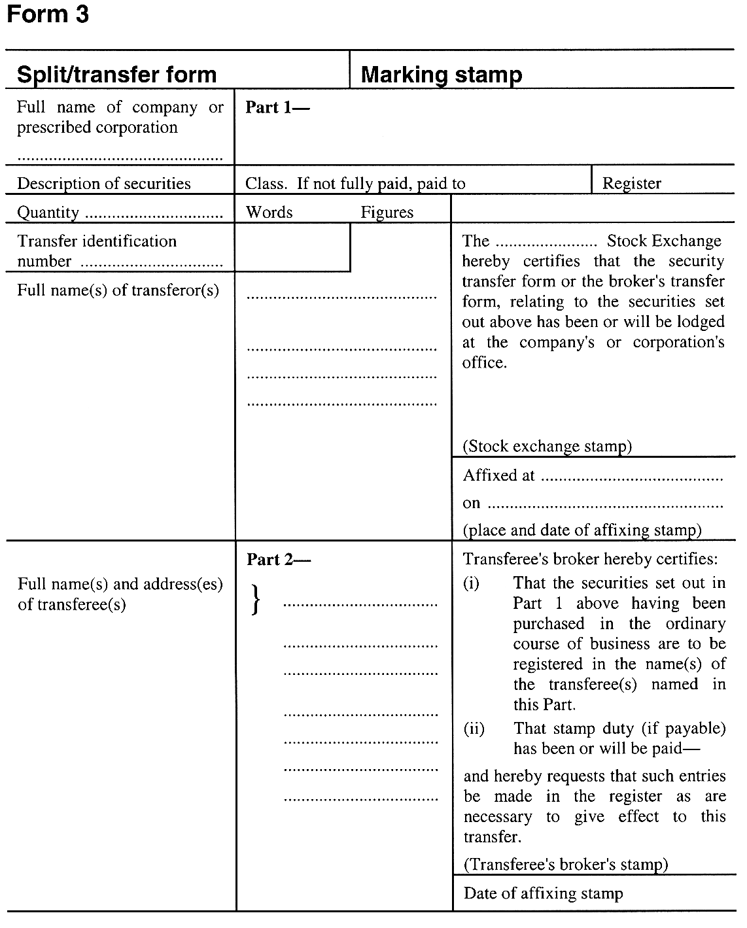
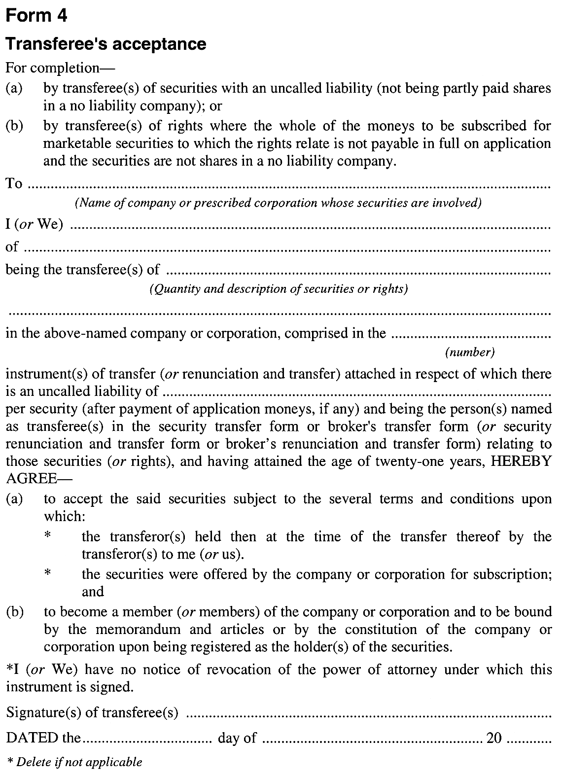
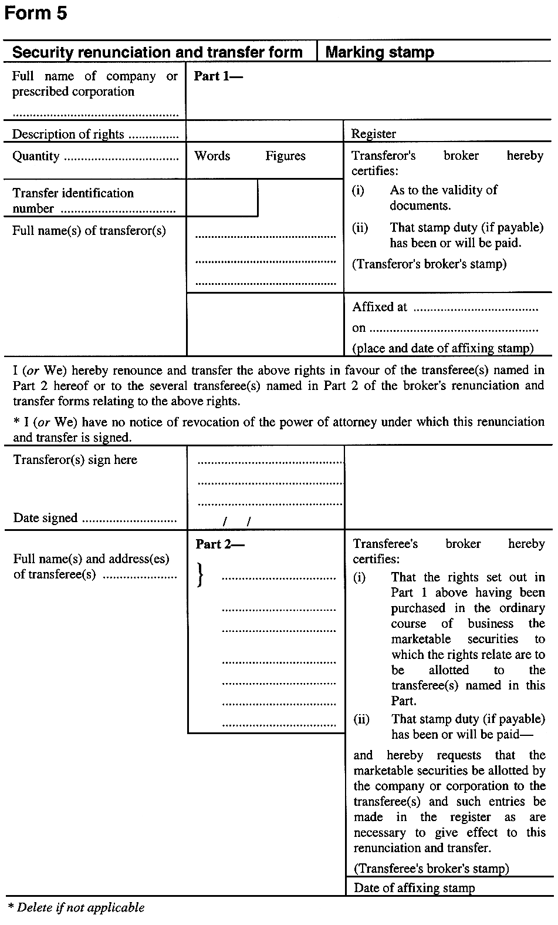
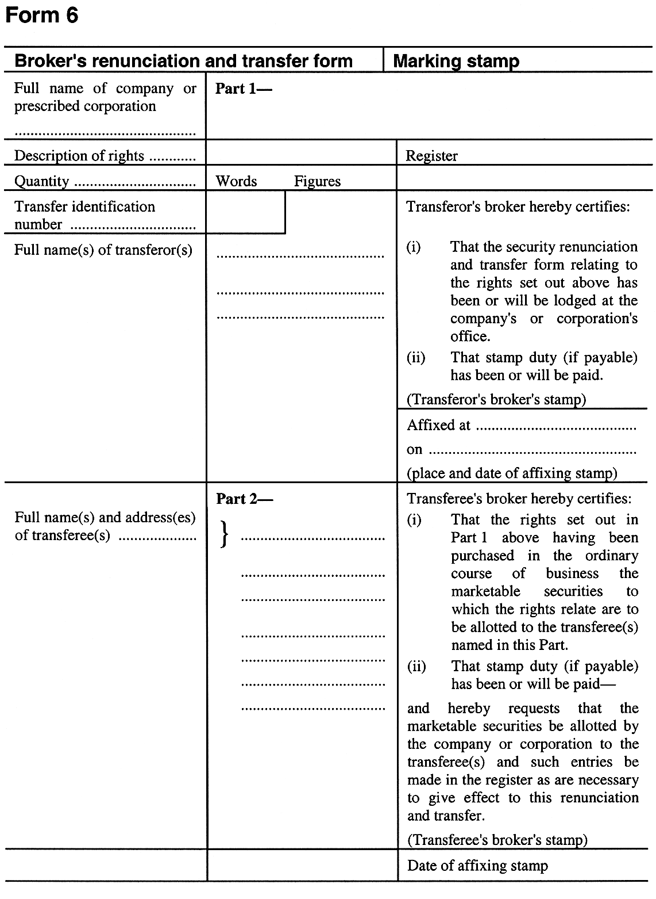
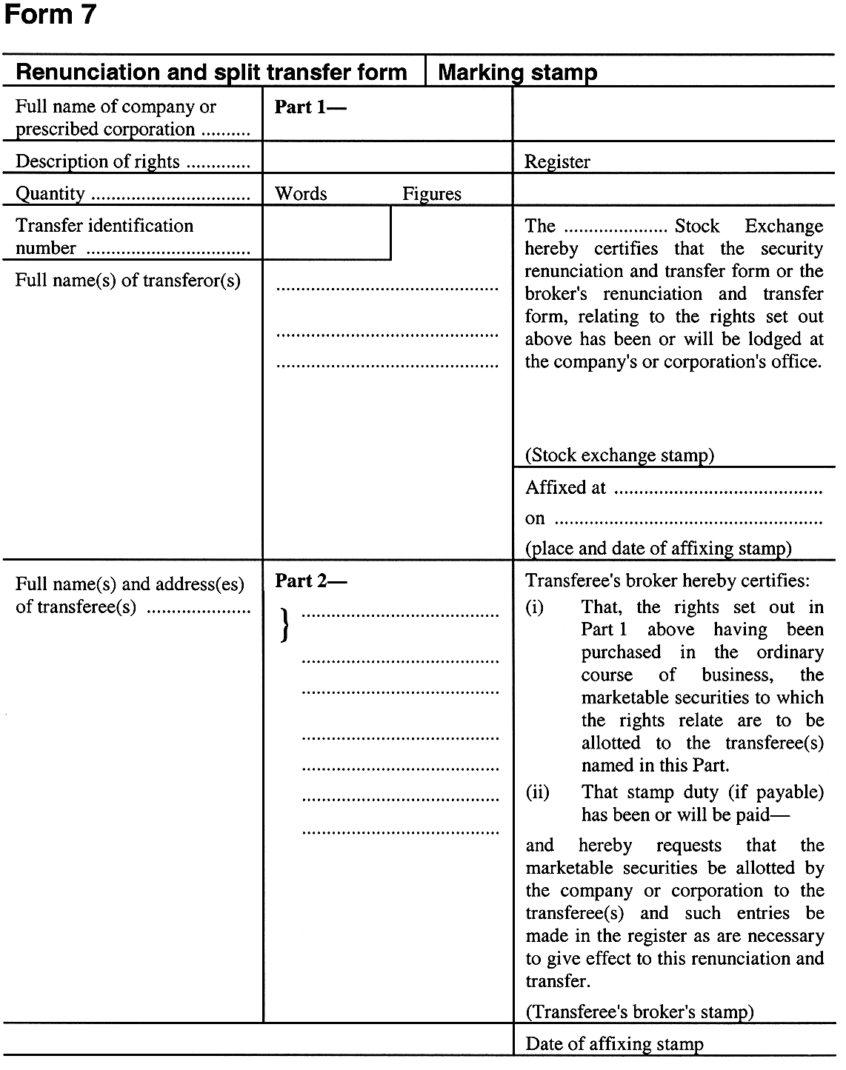
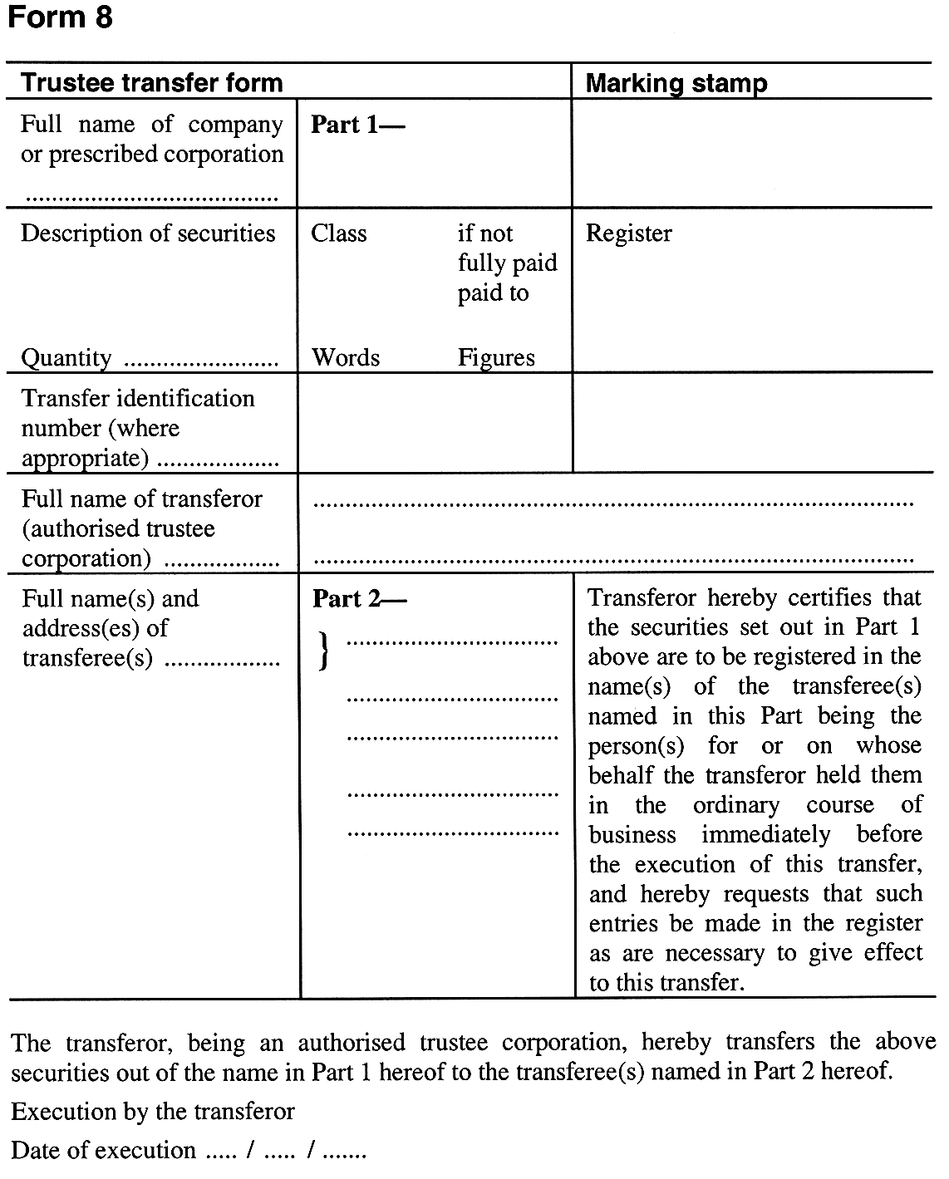
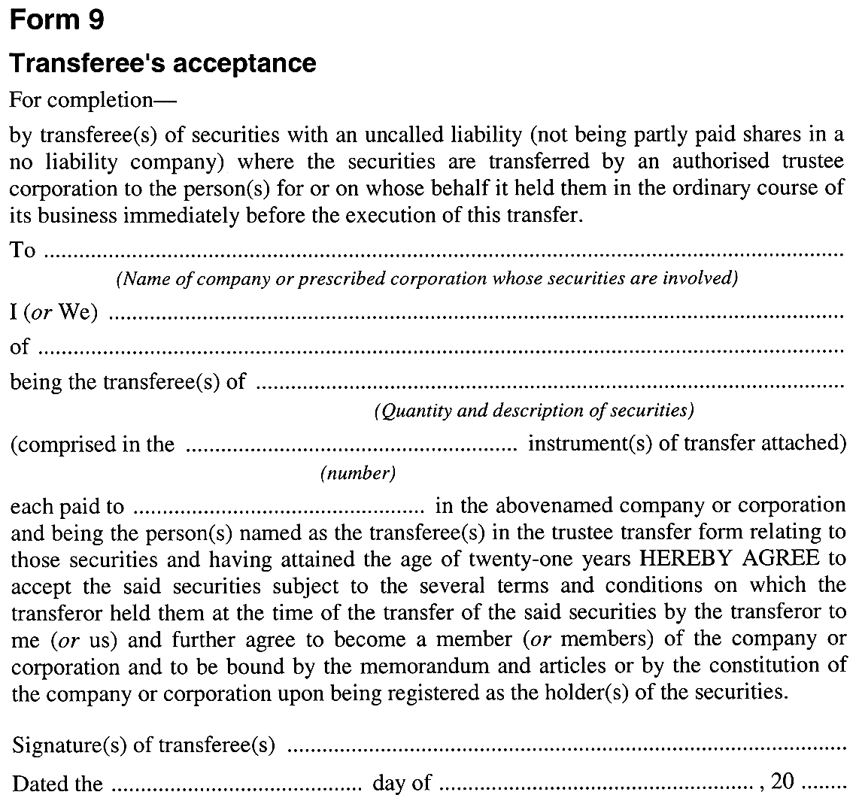
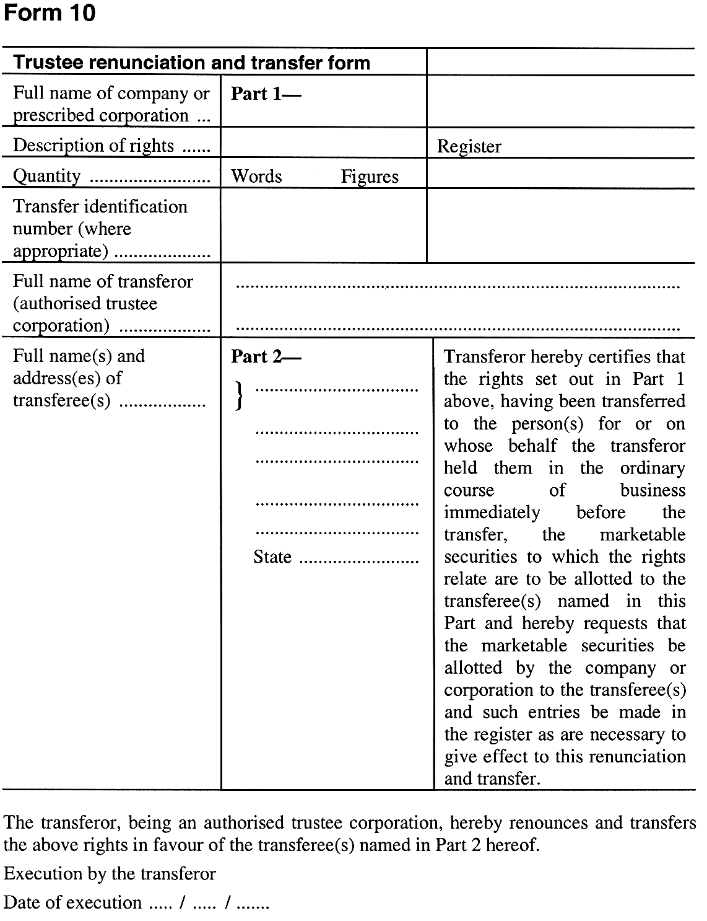
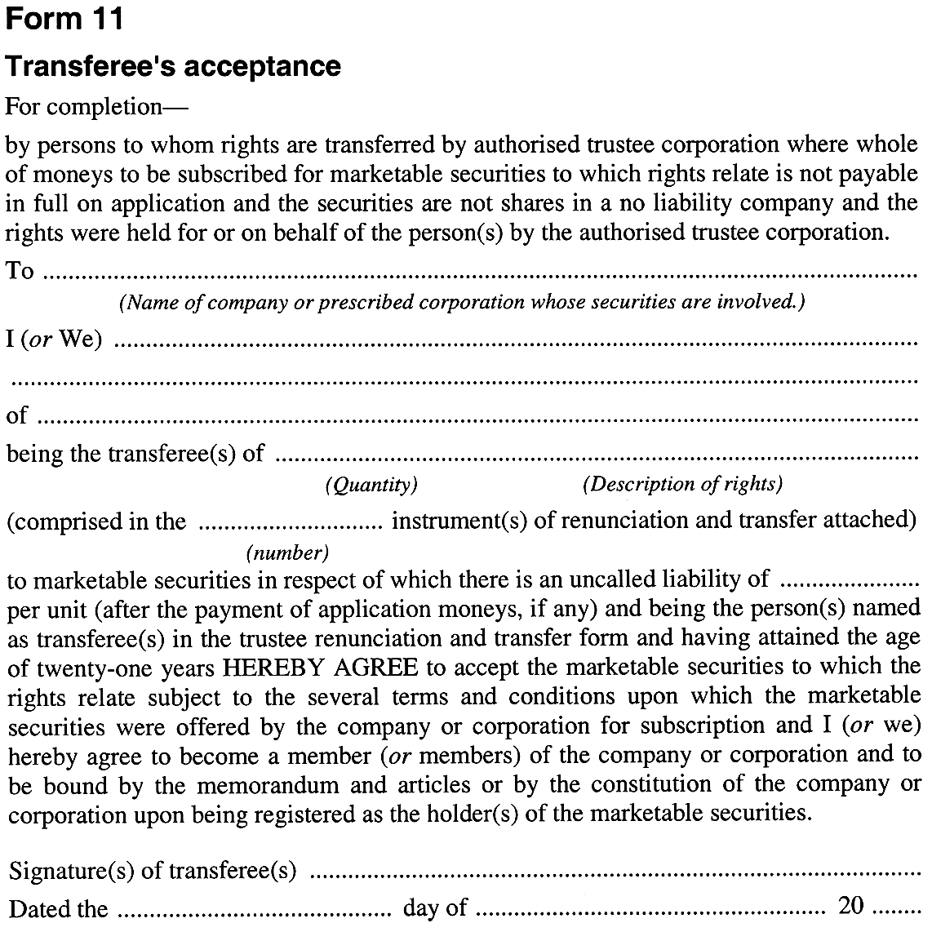

Legislative history
Notes
• For further information relating to the Act and subordinate legislation made under the Act see the Index of South Australian Statutes or www.legislation.sa.gov.au.
Principal Act
Year | No | Title | Assent | Commencement
1971 | 11 | Marketable Securities Act 1971 | 1.4.1971 | 1.7.1971 (Gazette 1.7.1971 p2)

